# COLLABORATIVE PROJECT WITH INTEL

# PROJECT TITLE: ACCIDENT LOCATIONS ON INDIAN ROADS

## TEAM NAME: TEAM STINGRAYS

**TEAM MENTOR:** Dr T V RAJINIKANTH

PROFESSOR & HEAD

DEPARTMENT OF CSE-(AI&ML)

**Email id:** [**rajinikanthtv@sreenidhi.edu.in**](mailto:rajinikanthtv@sreenidhi.edu.in) **,** [**rajinitv@gmail.com**](mailto:rajinitv@gmail.com)

**Phone No: 9849414375**

**Team Members:**  A Mallika Reddy Roll no: 21311A6613 CSE (AI&ML) Team lead

Sunkara SahrudaiRoll no: 21311A6630 CSE(AI&ML) -Team member

**Institute Name** : Sreenidhi Institute of Science and Technology

Yamnampet, Ghatkesar, Hyderabad - 501301

**Date of submission** : 15 -07- 2023

**ABSTRACT:** The project report focuses on identifying and analyzing the road accident locations (blackspots) on Indian roads and taking proper measures to reduce the road accidents. According to **Ministry of Road Transport and Highways of India**, A road accident Black spot is a stretch of road about 500m in length in which either 5 road accidents (in all three years put together involving fatalities/grievous injuries) took place during the last 3 calendar years or 10 fatalities (in all three years put together) took place during the last 3 calendar years.

Generally majority of road Accidents frequently occur, due to two main reasons, one is drivers mistake due to over speed, due to avoiding signals, may be due to ignoring traffic rules and the second case is external factors like road conditions, atmospheric conditions. Considering these two main factors this report suggests strategies such as awareness campaigns, driver education, infrastructure improvement (proper sign boards, proper lane markings and weather proof roads etc.) usage of safety equipment and speed management. By implementing such strategies road safety will be enhanced and therefore road accidents will gradually reduce.

**INTRODUCTION**

India is home to the second largest road network in the world with a total road length of approximately 62.1 lakh kilometers. While roads remain synonymous with development and growth in the country, they have also been a nemesis for travelers with India also carrying the dubious distinction of leading the global tally of annual deaths and injuries on account of road accidents. An asymmetry exists between number of vehicles and deaths due to road accidents with **India’s one percent global share of number of vehicles accounting for almost 11% deaths due to road accidents.** Road accidents continue to remain the leading cause of deaths, disabilities and hospitalizations in the country despite concerted efforts at all levels to contain these.

* The Aim of this project report is to analyze and present the blackspots on Indian roads. Depict those spots on Indian Map using AI Technologies. This knowledge will serve as a foundation for proposing strategies and taking measures to enhance the road safety across the country. The project will utilize comprehensive accident data collected from official sources including government records, police records, and accident databases. Advanced techniques will be applied to identify accident hotspots, trends, and patterns

.

**MOTIVATION**

* The motivation foridentifying and analyzing road accident locations is to implement various strategies in order to reduce the road accidents across the country.
* By identifying road accident locations (blackspots) , researchers can know the reasons for frequent accidents at a particular location and they can develop new methods and techniques to overcome these challenges and enhance the road safety.
* The Intel Industrial Training initiative Unnati Program helps the students in getting the flavor of Industrial View of the work planning, interaction and guidance of Intel Team and friendly competing with students across the nation.

**DATA SOURCES**

Downloaded blackspot locations data from the official website of ministry of road and transportation of India i.e <https://morth.nic.in/black-spot> and official telangana state police website .

Developed a code that takes the locations of the blackspots and map them according to their latitudes and longitudes given as an input.

**SOURCE CODE**

<https://github.com/Mallikareddie/accidentlocations>

**RESULT:**

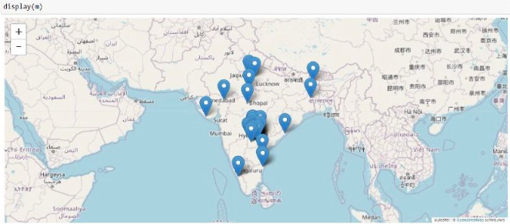

**CONCLUSION**

Blackspots were identified and through proper research and analysis we can understand the reasons for frequent accidents in the blackspots and we can implement the strategies accordingly in order to reduce the road accidents across the nation and enhance the road safety .

**FUTURE SCOPE**

This project can be started as first step to explore the GIS tools of Python. And can be improved to develop various Apps to assist the drivers.

**REFERENCES**

* <https://morth.nic.in/>
* <https://bro.gov.in/WriteReadData/linkimages/5768690382-14.pdf>
* <https://www.transport.telangana.gov.in/html/road-safety.html>
* <https://warangalpolice.telangana.gov.in/road-safety-preventive-measures>